User Manual for the IMA System Integration and Verification Bench Reflect Memory Converter

Prepared by:

GE AVIC Civil Avionics Systems Company Limited (“AVIAGE SYSTEMS”)

Floor 1, Building 3, Digital Hub, 555 Dong Chuan Road, Min Hang District, Shanghai, 200241, PRC

|  |
| --- |
| GE AVIC Civil Avionics Systems (“AVIAGE SYSTEMS”) Proprietary Information 中航通用电气民用航电系统（“昂际航电”）专属信息 |
| The information in this document is GE AVIC Civil Avionics Systems Company Limited (“AVIAGE SYSTEMS”) Proprietary Information and is disclosed in confidence. It is the property of AVIAGE SYSTEMS and shall not be used, disclosed to others or reproduced without the express written consent of AVIAGE SYSTEMS. If consent is given for reproduction in whole or in part, this notice shall appear in any such reproduction in whole or in part. 本文件中所含信息是中航通用电气民用航电系统有限责任公司（以下简称“昂际航电”）的专有信息，属非公开信息。该信息为昂际航电财产。未经昂际航电明确书面同意，不得使用、泄露或复制该信息。允许复制全部或部分信息时，应在复制品上标明本提示。 |

© GE AVIC Civil Avionics Systems Company Limited (“AVIAGE SYSTEMS”), 2014

© 中航通用电气民用航电系统有限责任公司（“昂际航电”），2014

**Release Status**

**Disclaimer:** This document is not considered released unless the **Release Date** and **Released By** columns are filled out for this revision.

Revision Levels

Revision level is indicated in the document header and the **Rev.** column below, and is of one of the following types:

**Developmental:** Used for project drafts and not considered a “Formal Release”, and cannot be sent to a customer to fulfill a contractual delivery requirement. Revisions are indicated by X1, X2, X3, etc.

**Pre-Production:** Preliminary revisions, considered a “Formal Release”. Can support DRL deliveries to the customer if the contractual requirements are met. Pre-production documents undergo a pre-production checking and approval process prior to release. Revisions are indicated by 1, 2, 3, etc.

**Production:** AVIAGE SYSTEMS’ highest level of control and best effort as a company. Supports full-production efforts. Provides sufficient information to fabricate, assemble, and test deliverable production units produced in Engineering or Manufacturing. Revisions are indicated by –, A, B, C, etc.

Revision History

| **Change Order** | **Rev.** | **Rev. Date** | **Change Description** | **Release Date** | **Released By** |
| --- | --- | --- | --- | --- | --- |
|  | — | 140605 | Initial Creation |  | Julian.Xie |
|  |  |  |  |  |  |

Table of Contents

Section Page

1. Introduction 4

1.1 Purpose 4

1.2 Scope 4

1.3 Definition of Terms 4

1.4 Used Tools 4

2. Referenced Documents 4

3. User Manuals 4

3.1 Environment and Tools 4

**3.1.1** Supporting Files 5

**3.1.2** Environment 5

**3.1.3** Additional Tool: Model Bridge 5

3.2 Get I-SIVB RMC Software Files 5

3.3 Operation 5

# Introduction

## Purpose

This document has been prepared by GE AVIC Civil Avionics Systems Company Limited, hereinafter called AVIAGE SYSTEMS. This document describes the procedures to build the software correctly.

## Scope

This document could only be used to build the SOFTWARE, IMA System Integration and Verification Bench Reflect Memory Converter, with AVIAGE SYSTEMS part number XXXXXXX, Rev 1.

## Definition of Terms

|  |  |
| --- | --- |
| I-SIVB | System Integration and Verification Bench for  IMA system |
| I-SIVB RMC | I-SIVB Reflect Memory Converter |
| VAIS | Virtual Aircraft Integration Software |

## Used Tools

The following tools or software are used or to be used together with I-SIVB RMC software.

|  |  |
| --- | --- |
| VAI Control Panel | VAI Tool provide by GE. |
| General Model Bridge | Software developed by AVIAGE SYSTEMS, to convert VAIS parameters in different protocal (ARINC664 to ARINC429, for example). |

# Referenced Documents

The following documents of the exact issue shown form a part of this document to the extent specified herein. For those documents showing no date of issue, the latest issue applies.

AVIAGE SYSTEMS

|  |  |
| --- | --- |
| ED3688  XXyyyy | Software Development Plan for Test Systems Software.  Design document for I-SIVB Reflect Memory Converter. |

COMAC

|  |  |
| --- | --- |
| E-C289JB054 | C919 Aircraft Avionics Laboratory Reflective Memory Network User Standard. |

# User Manuals

## Environment and Tools

### Supporting Files

Table 2. Supporting Files and Libraries Baselines

|  |  |
| --- | --- |
| **Baseline ID** | **Software Name** |
| SIM:1000065-001_VENDOR | SOFTWARE, VENDOR, VIRTUAL AIRCRAFT INTEGRATION SYSTEM |
| SIM:1000065-00X_VENDOR | SOFTWARE, VENDOR, GE Intelligent Platforms, PCI RFM2g Card Driver. |

### Environment

Computer installation: Desktop PC

Operating system: Windows 7 Pro 64-Bit (1000060-001)

Compiler(s): VS2010 + Service Pack 1 (1000061-001)

Assemblers: VS2010 + Service Pack 1 (1000061-001)

### Additional Tool: Model Bridge

YOU SHOULD USE MODEL BRIDGE TO MATCH THE NPD MESSAGES WITH REAL ICD.

## Get I-SIVB RMC Software Files

1. In Dimensions, perform a Get action for the folder **… \Sim\Product\I-SIVB-ReflectMemoryConverter\I-SIVB-ReflectMemoryConverter\bin\Release**

Except for I-SIVB-ReflectMemoryConverter.exe, other dynamic link libraries are also in need.

1. In Dimensions, perform a Get action for the folder **… \Sim\Product\I-SIVB-ReflectMemoryConverter\Configuration**

Following is the list of files:

| VAIS_Config.vaisproj

| VAIS_Config.system

| VAIS_Config.resource

| VAIS_Config.participant

| VAIS_Config.icduser

| VAIS_Config.icdimport

| I_SIVB_Config.xml

## Operation

Step1: Open VAIS_Config.vaisproj, using VAI Configuration Editor, see the figure1.

In the Utility Participants configuration page, the following parameters may be in need of modification.

1. The Startup File Path can be modified to the real location if not.
2. The Startup Parameters should be the I_SIVB_Config.xml path.
3. The Utility Name/Description shall be the same as the content in the I_SIVB_Config.xml:

<I-SIVBParticipant name = "I-SIVB RMC" description = "AVIAGE" partNumber = "1" version = "1"/>

</I-SIVBconfig>

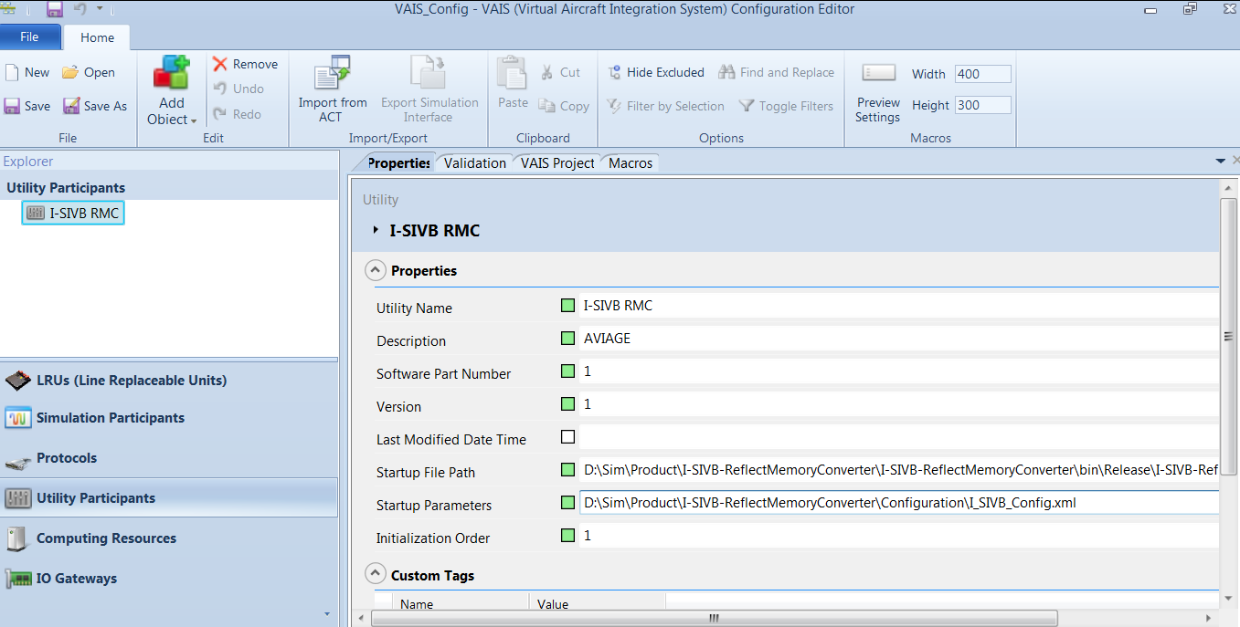

Figure 1. VAIS_Config.vaisproj

Step2: Open I_SIVB_Config.xml.

The following parameters may need change:

1. VaisConfigPath

For example:

<VaisConfigPath value="D:\\Sim\\Product\\I-SIVB-ReflectMemoryConverter\\Configuration\\VAIS_Config.icduser"/>

1. Reflect memory configurations:

Here is an example:

<RfmDevice id= "0" byteSwap="true" />

<SourceSelection firstSelection="IronBird">

<IronBirdData1>

<Data offset="B09000" end="B09FFF"/>

</IronBirdData1>

<FCSMiniRigData1>

<Data offset="B07000" end="B07FFF"/>

</FCSMiniRigData1>

</SourceSelection>

<Data4Message>

<Data4 offset="B0C000" end="B0CFFF"/>

</Data4Message>

1. Refresh rate:

Here is an example:

<RefreshRate value="50"/>

Step3: Open CommonSimRuntime.exe

Step4: Load the VAIS_Config.vaisproj, using VAI ControlPanel.exe. And Run All to start the software, it is shown in Figure 2

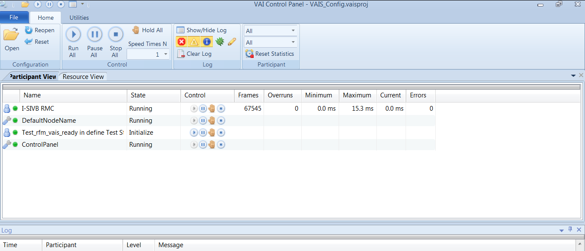

Figure 2. VAI Control Panel